[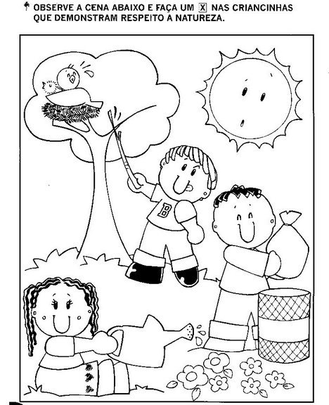](http://www.google.pt/url?sa=i&rct=j&q=&esrc=s&source=images&cd=&cad=rja&uact=8&ved=0ahUKEwiy0uPYwaXLAhWBgBoKHcxnD4oQjRwIBw&url=http://www.baudeatividades.com/2013/05/atividades-de-ciencias-e-meio-ambiente.html&psig=AFQjCNFO7CFNV7tb7KT3pSahSO91TSBa3g&ust=1457128679057709)