[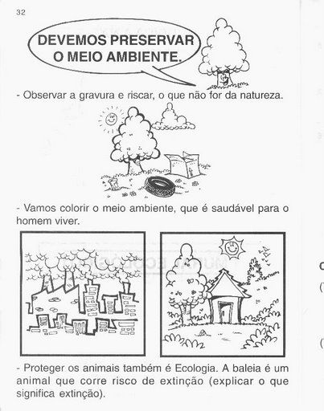](http://www.google.pt/url?sa=i&rct=j&q=&esrc=s&source=images&cd=&cad=rja&uact=8&docid=Jgy0TwjaFkiN0M&tbnid=9Kip1xf2Uf8adM:&ved=0CAUQjRw&url=http://www.nachaca.com/sugestoes-de-atividades-infantil-para-o-dia-mundial-do-meio-ambiente/&ei=Um5-U9WEE9Cz0QW59oCoBA&bvm=bv.67229260,d.ZGU&psig=AFQjCNGcbqBdkYc-Ccx-w69MEP7M973JCw&ust=1400881042308125)