Nome:_________________________________________
Data:_________________________________________

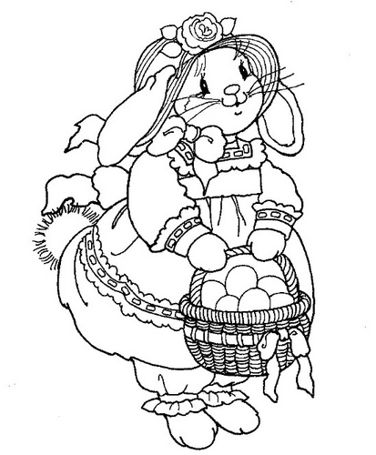

Nome:_________________________________________
Data:_________________________________________

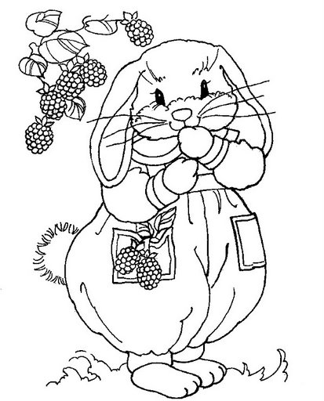
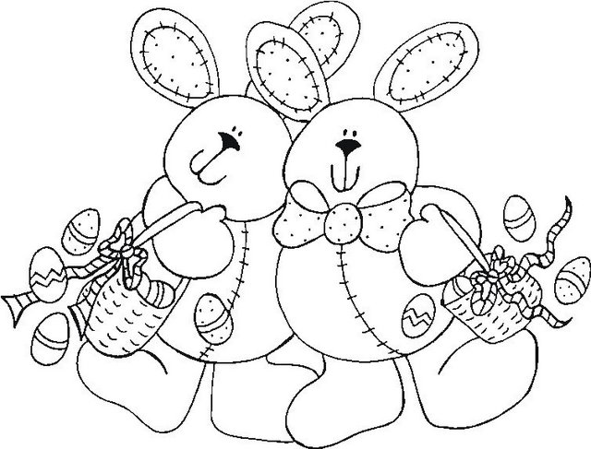

Nome:_________________________________________
Data:_________________________________________

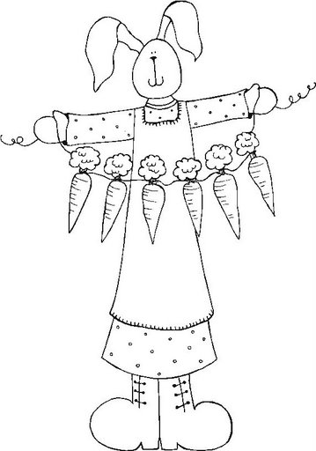
Nome:_________________________________________
Data:_________________________________________

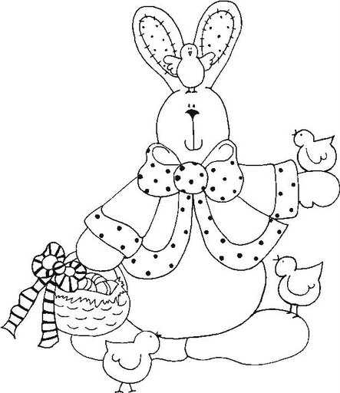
Nome:_________________________________________
Data:_________________________________________

Nome:_________________________________________
Data:_________________________________________

Nome:_________________________________________
Data:_________________________________________
Nome:_________________________________________
Data:_________________________________________

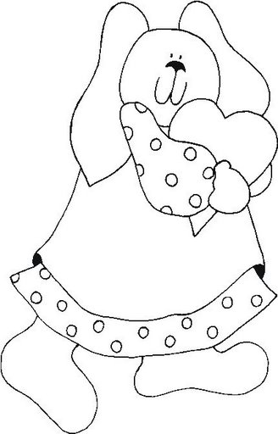

Nome:_________________________________________
Data:_________________________________________

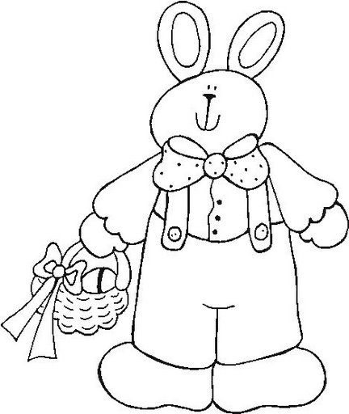

Nome:_________________________________________
Data:_________________________________________




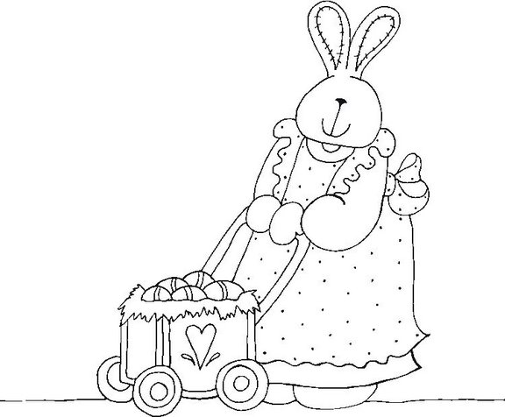
Nome:_________________________________________
Data:_________________________________________

Nome:_________________________________________
Data:_________________________________________

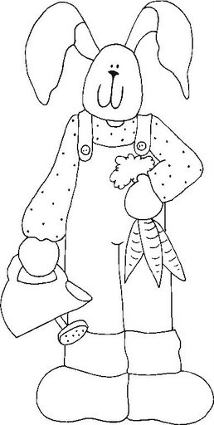

Nome:_________________________________________
Data:_________________________________________

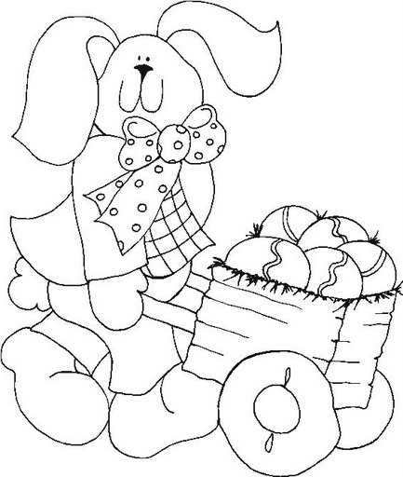


Nome:_________________________________________
Data:_________________________________________
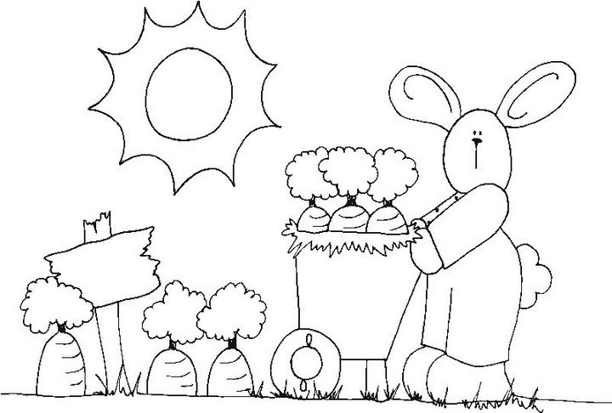
Nome:_________________________________________
Data:_________________________________________

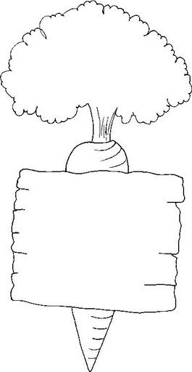

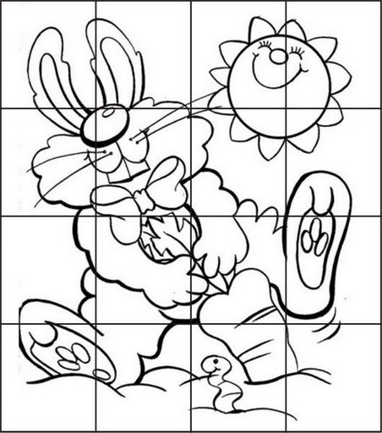
Nome:_________________________________________
Data:_________________________________________

Nome:_________________________________________
Data:_________________________________________

Nome:_________________________________________
Data:_________________________________________

Nome:_________________________________________
Data:_________________________________________



Nome:_________________________________________
Data:_________________________________________
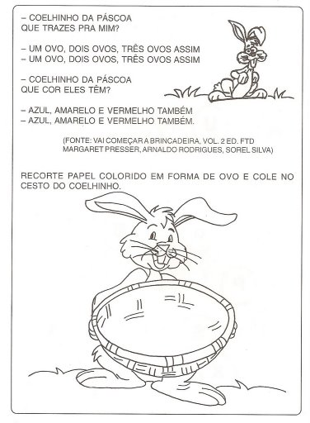

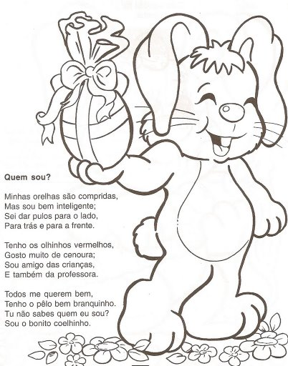
Nome:_________________________________________
Data:_________________________________________

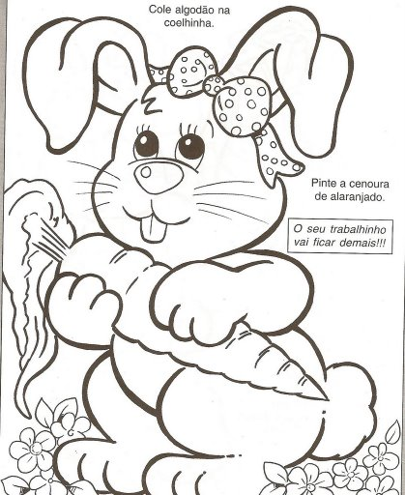

Nome:_________________________________________
Data:_________________________________________

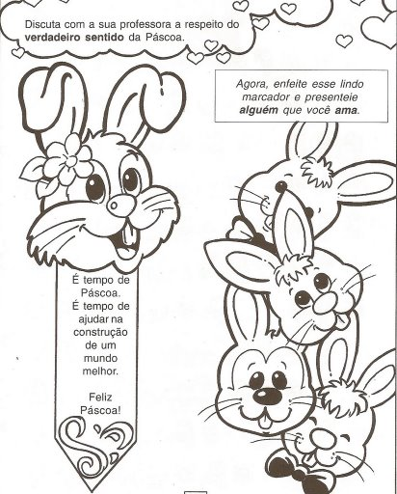



Nome:_________________________________________
Data:_________________________________________

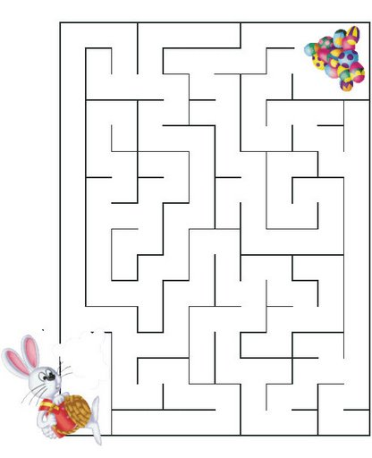
Nome:_________________________________________
Data:_________________________________________

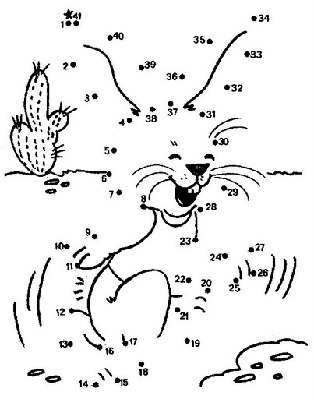
Nome:_________________________________________
Data:_________________________________________


Nome:_________________________________________
Data:_________________________________________

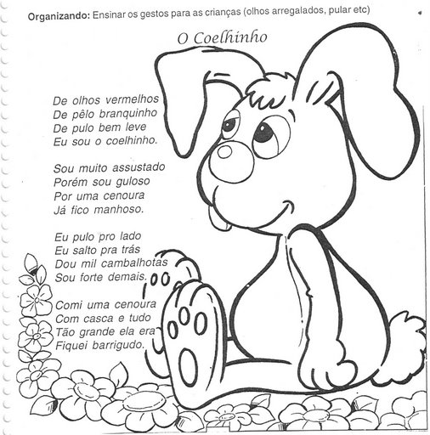
Nome:_________________________________________
Data:_________________________________________

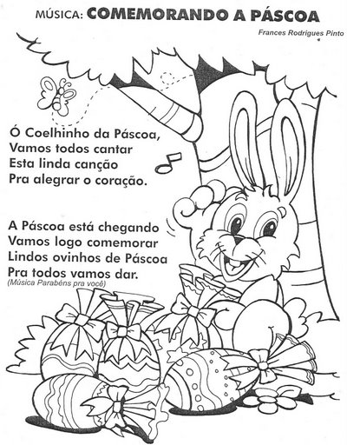
Nome:_________________________________________
Data:_________________________________________
Nome:_________________________________________
Data:_________________________________________

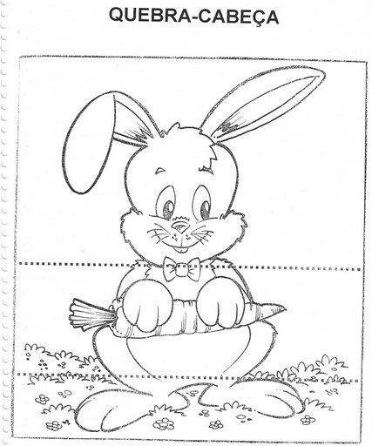

Nome:_________________________________________
Data:_________________________________________

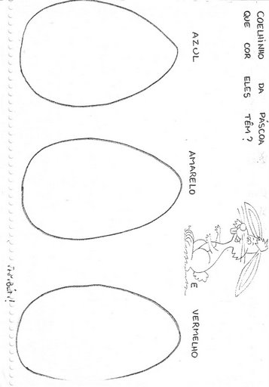

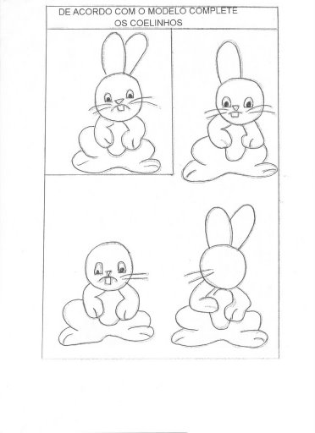
Nome:_________________________________________
Data:_________________________________________

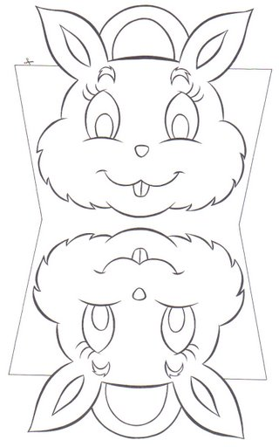


Nome:_________________________________________
Data:_________________________________________
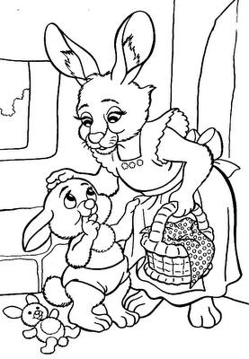
Nome:_________________________________________
Data:_________________________________________



Nome:_________________________________________
Data:_________________________________________


Nome:_________________________________________
Data:_________________________________________

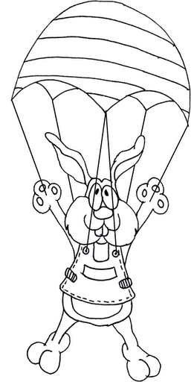

Nome:_________________________________________
Data:_________________________________________


Nome:_________________________________________
Data:_________________________________________



Nome:_________________________________________
Data:_________________________________________

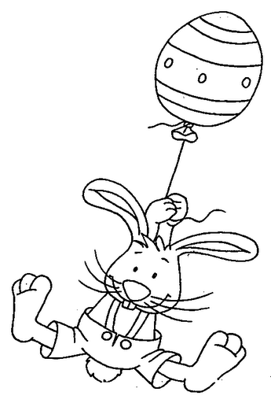
Nome:_________________________________________
Data:_________________________________________

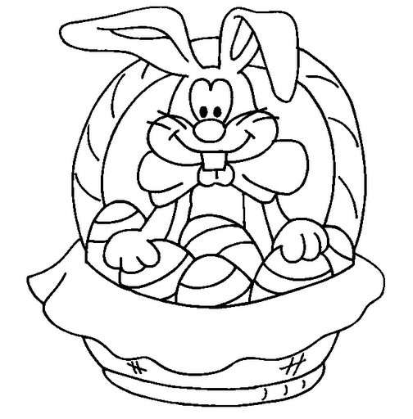
Nome:_________________________________________
Data:_________________________________________

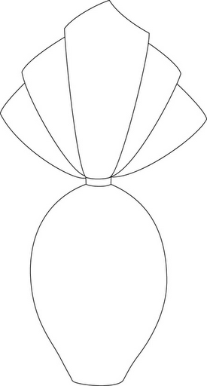

Nome:_________________________________________
Data:_________________________________________

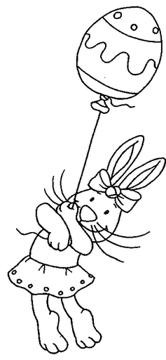

Nome:_________________________________________
Data:_________________________________________



