[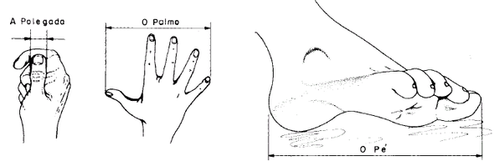](http://www.google.pt/url?sa=i&rct=j&q=&esrc=s&source=images&cd=&cad=rja&uact=8&ved=0ahUKEwiImtz5gYLLAhWIPRoKHaCQADEQjRwIBw&url=http%3A%2F%2Fwww.ebah.com.br%2Fcontent%2FABAAAAwQ0AJ%2Fmedidas-medicoes-metrologia&psig=AFQjCNEnrG-INYhfi58uajpPTjjE76QqAg&ust=1455908998659650)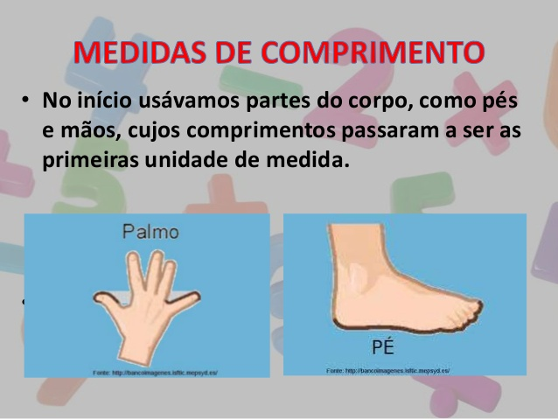

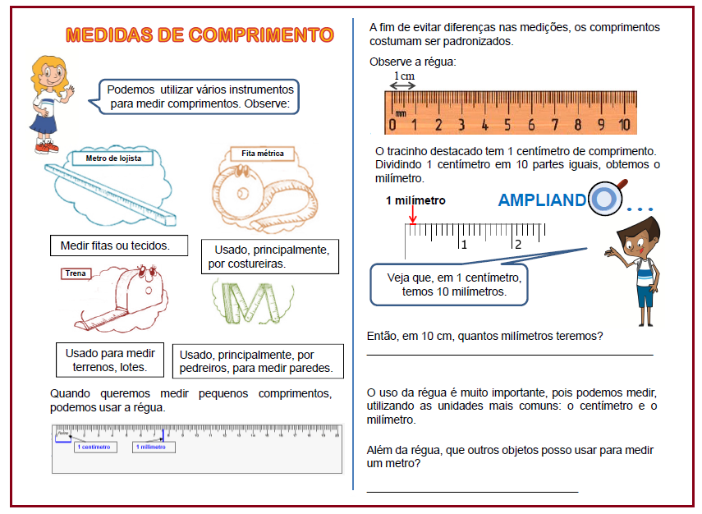

Fita métrica

Metro articulado

[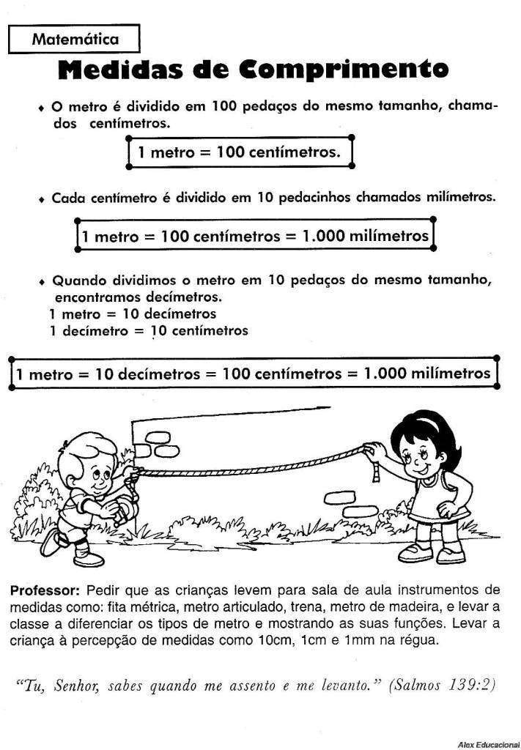](http://www.google.pt/url?sa=i&rct=j&q=&esrc=s&source=images&cd=&cad=rja&uact=8&ved=0ahUKEwjolrO6hYLLAhWG0hoKHTKACigQjRwIBw&url=http%3A%2F%2Feducacaodevalor.blogspot.com%2F2011%2F07%2Fatividades-medidas-de-comprimento-metro.html&psig=AFQjCNGIP76VqjzLy_aLBnnGu7HrOqyZkA&ust=1455909490817942)[](https://www.google.pt/url?sa=i&rct=j&q=&esrc=s&source=images&cd=&cad=rja&uact=8&ved=0ahUKEwjPq-OehYLLAhXB0hoKHatGDaMQjRwIBw&url=https%3A%2F%2Freridamaria.wordpress.com%2F2015%2F04%2F13%2Fmedidas-de-comprimento%2F&psig=AFQjCNGIP76VqjzLy_aLBnnGu7HrOqyZkA&ust=1455909490817942)

